**Project Repo :** <https://github.com/kshrikantk/Hello_Proj>

**Library Repo** : <https://github.com/kshrikantk/jenkins_shared_libraries>

**Here is the scenario which I have consider :**

1. Need to build and deploy .net code.

2. github as a repository

3. Every branch should be built. (multibranch pipeline )

4. Jenkinsfile (groovy) code should be reusable.

Made it reusable by creating Jenkins library

to get it execute define library at :

Jenkine -> Configure -> Global Pipeline Libraries

**As shown Bellow :**

**Shared library Repo : git@github.com:kshrikantk/jenkins_shared_libraries.git**

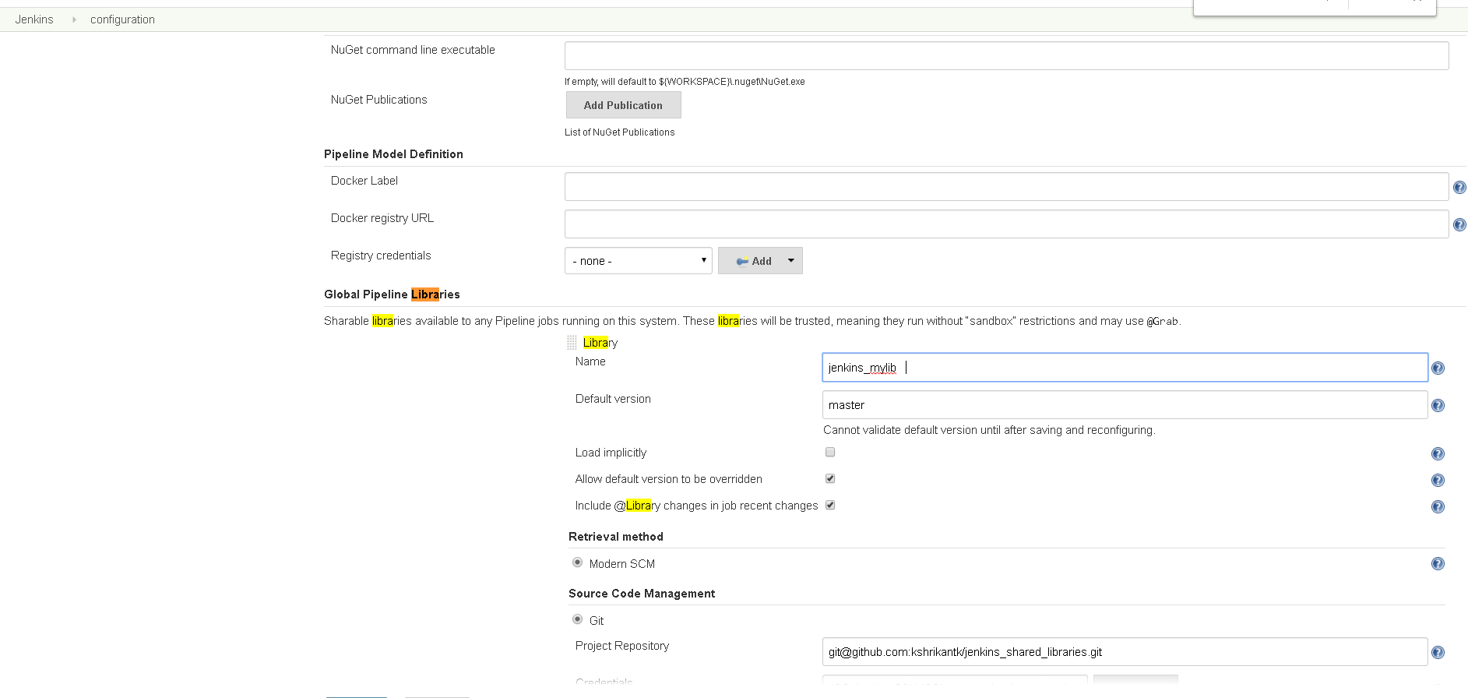

5. Jenkins file should import library using

@Library('jenkins_mylib@master')

6. Jenkins file should run below stages :

1. **cleanup** : To clean working dir / workspace

2. **Checkout** : To Checkout code repo

3. **Versioning** : To calculate version to apply on dlls , exe file getting created. Provide base version ‘major.minor.patch’ in to the version.txt file.

4. **Naming** : To change name of build to match version number

5. **Nuget** restore : To restore Nuget packages

6. **Build** : To run msBuild

7. **Unit tests** : To run Unit test

8. **Code Coverage :** To run Code coverage and generate report

9. **HTML Report Publish :** To display code coverage as a Html report

10**. Nuget Pack :** To pack Nuget to publish to Artifactory

11. **Nuget Push :** In case of master release or develop branch nugget should get push to Artifactory

12**. Archive Artifacts :** Archive artifacts

**Feature provided:**

Code is reusable, and easily maintainable also can be used for multiple branch.

|  |  |
| --- | --- |
|  |  |
|  | | |